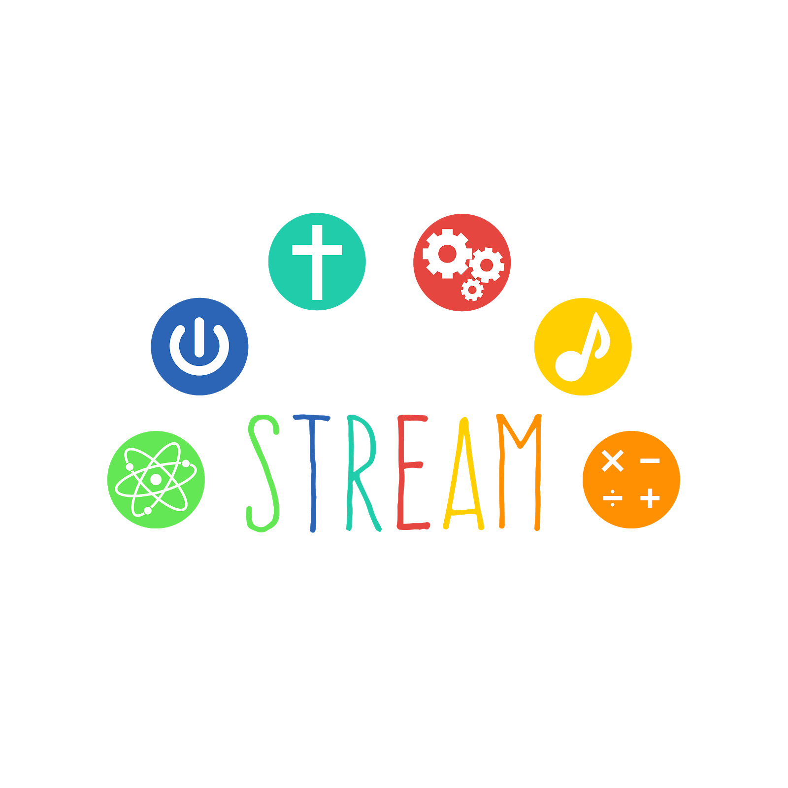
STREAM NEWS SCIENCE, TECHNOLOGY, RELIGION, ENGINEERING, ARTS, MATH
SEPTEMBER 2019
WHAT’S HAPPENING WITH STREAM
OUR STAFF SPENT TIME THIS SUMMER PREPPING FOR STREAM CLASSES THAT ENRICH OUR ACADEMIC CURRICULUM WITH CONTENT CONNECTIONS. WE DEVELOPED A PROCESS THAT WE WILL FOLLOW WHEN PRESENTING OUR STREAM LESSONS.
WE WILL USE KIDBLOG AGAIN THIS YEAR FOR STUDENTS TO POST PICTURES (SEE THE KINDERGARTEN PLAN) AND BLOG WITH EACH OTHER ABOUT THEIR PROJECTS.
CLASS PROJECTS IN DEVELOPMENT
NOTE: OUR PROJECT PLANS ARE DEVELOPING! THE STUDENTS LEAD THESE PROJECTS
AND THE PATHS WE TAKE TO ANSWERING THE DRIVING QUESTION VARIES. PLEASE NOTE THAT THESE PROJECTS REALLY ARE DEVELOPING!
OUR STREAM PROJECTS INSPIRE US TO LEARN MORE AND EXPLORE THE MANY DIFFERENT WAYS THAT WE CAN BUILD, DISCOVER AND/OR ENGINEER!
ALL OUR TEACHERS ARE GETTING TO KNOW THEIR STUDENTS, THEY ARE PLANNING PROJECTS THAT THE STUDENTS WILL BE INTERESTED IN AND HAVE AN IMPORTANT ROLE IN DEVELOPING. SOME OF THE PROJECTS WE’VE BEGUN ARE LISTED BELOW:
PRESCHOOL: WILL THE BIRDS COME TO THE BIRD FEEDER EVERY DAY? WE WILL COLLECT DATA BY OBSERVING BIRDS ON OUR WINDOW BIRD FEEDER!
KINDERGARTEN: HOW CAN WE RECORD OUR BUILDING PROJECTS? KINDERGARTEN STUDENTS LOVE TO BUILD AND THEY ARE CREATING AN ENGINEER PROJECT THAT WILL BE PHOTOGRAPHED BY EACH STUDENT! WE WILL POST IT ON OUR KIDBLOG!
FIRST AND SECOND GRADE: IS OUR PRESCHOOL PLAYGROUND FUN? ALREADY ON A ROLL, THE FIRST AND SECOND GRADE STUDENTS HAVE TESTED OUT THE PLAYGROUND, THEYARE DESIGNING A PLAYGROUND AND WILL BUILD A PROTOTYPE.
THIRD AND FOURTH GRADE: HOW CAN WE INCLUDE THE SEVEN CATHOLIC SOCIAL TEACHINGS IN OUR STREAM PROJECTS? SHHHHH....PLEASE DON’T TELL BUT THE THIRD AND FOURTH GRADE ARE GOING TO CREATE AN ESCAPE PUZZLE PLAN AND ASK THE FIFTH AND SIXTH GRADE STUDENTS IF THEY CAN FIGURE IT OUT?
FIFTH AND SIXTH GRADE: CAN THE INVENTIONS OF HENRY FORD INSPIRE US TO CREATE OUR OWN INVENTIONS? WE WILL BEGIN OUR RESEARCH WHICH INCLUDES A FIELD TRIP TO THE DETROIT HENRY FORD MUSEUM.
FUTURE PROJECTS
WE HAVE BEGUN TO DEVELOP A MEDIA CENTER AND STREAM LAB IN OUR LIBRARY AND COMPUTER LAB SPACE. WE HOPE THIS WILL BE A WONDERFUL AREA WITH LIBRARY SERVICES AND STREAM CLASSES THAT CAN HAVE SUCH THINGS AS MAKER SPACE PROJECTS, DESIGN AND ENGINEERING SPACE, SCIENCE EXPERIMENT POSSIBILITIES, AND MUCH MORE! 2
LEGO BOARD
The Lego Board this month is coded. Each letter has it’s own code. These are combinations
of 0 or 1, our 0’s are white Legos, and 1’s are red Legos. This has proven to be challenging
because as you will see it’s easy to get lost when writing with red and white legos only!
The phrase we are creating is:
With the Holy Spirit We are Rolling Along in the Path of Jesus

